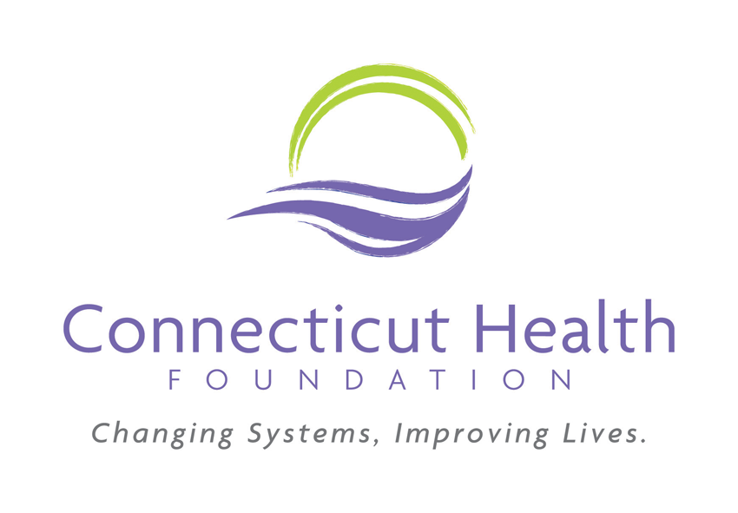
DIRECTOR OF POLICY
Job Description

Department: Program
Reports to: VP of Program

The Connecticut Health Foundation, a state-wide, private health foundation, works to eliminate racial and ethnic health disparities. CT Health approaches this goal by focusing on systems change, specifically focusing on shifting policies and practices to advance changes that can lead to racial health equity. As a private foundation, CT Health does not lobby or participate in electoral campaigns.
The director of policy works within a team that includes communications and grantmaking expertise. The team works together to identify the best ways to achieve change, using a combination of policy advocacy, grantmaking, research, strategic communications, and investing in leadership. The foundation works to educate and inform policymakers and supports those advocating for health equity through policy change and other systems innovations that can improve people’s lives.

The director of policy guides the vision and strategy for the foundation’s health policy efforts. This position interfaces with state, local, and federal stakeholders, as well as grassroots and grasstops organizations that are advocating for a more equitable health care system. The director of policy is responsible for stewarding the policy process, from drafting the foundation’s policy agenda, to formulating and implementing initiatives, and finally to monitoring and evaluating how the foundation’s policy work advances CT Health’s mission.

Key responsibilities of this role include monitoring the landscape to identify ways to advance health equity through policy; working with existing grantees and partners to support their advocacy work and identifying potential new grantees and advocacy partners; working with the grantmaking and communications teams to identify holistic approaches to achieving the foundation’s goals; and maintaining strong relationships with policymakers, advocacy grantees and other constituents.

Someone who is successful in this role will:
- Be passionate about racial equity and understands how health disparities impact communities of color in Connecticut
- Feel comfortable navigating the state legislative process and understands how things work within state agencies and systems
- Cultivate relationships with grassroots and grasstops advocates
- Contribute to research and communications strategy to encourage systems change
- Enjoy working closely with others

Key Responsibilities:
- Develop strategies and approaches to actualize the foundation’s mission and strategic plan through public policy
- Draft an annual policy agenda which outlines the areas of focus and opportunity during a legislative session
- Identify and respond to emerging health policy issues that are pertinent to the foundation’s objectives
- Oversee monitoring of state and federal health policy activities related to public financing, health reform, regulations, legislation, and the foundation’s priority areas
- Cultivate strong relationships with select branches of government, the health community, advocates, grantees, and other funders, including providing technical assistance to CT Health grantees and partners
- Work collaboratively to develop and execute public policy-related research and educational briefing events
- Organize and facilitate convenings with experts, stakeholders, grantees, and other partners
- Work with senior management, and the board of directors to develop, execute and evaluate the foundation’s policy strategy, operating plan, and associated budget
- In partnership with the director of communications and strategic initiatives, guide the work of the Board and Public Policy and Communications Committee
- Represent the foundation on advisory committees, steering committees, and working groups, as well as at community and grantee events
- Approach policy and grantmaking work with humility and assure that external and internal partners are treated with respect and valued for the expertise they bring to the work

Qualifications and skills:

- Demonstrated commitment to racial equity and interest in health equity
- Understanding of and commitment to systems change
- Five or more years of experience in public policy, advocacy, government, public affairs, public
relations, or a related field; a background in advocacy desirable
- Expertise in health care or public health; an understanding of the changing landscape of health reform nationally and in Connecticut is a plus
- Experience with the public officials, and the health care, public health, non-profit, advocacy, and funder communities
- Ability to work independently and in teams and to inspire others to work toward achieving common goals
- Excellent written and verbal communication skills, exceptional public speaking skills and comfort representing the foundation
- Expertise in working with partners and grantees to build capacity and expertise in policy and advocacy
- Able to manage multiple priorities simultaneously
- Bachelor’s degree in a related field required, Master’s degree/advanced degree preferred experience will be considered in addition to educational achievement
- Excellent interpersonal skills: a leader, team player, and listener with a great sense of humor

