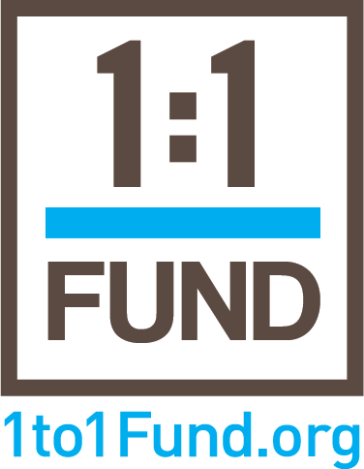
Match Kids’ College Dreams Dollar for Dollar
OUR MISSION

The 1:1 Fund supports the college dreams of low-income children by ensuring that those dreams are matched with savings in the bank. We make it easy for local children’s savings programs to raise matching funds from donors, large and small, thereby enabling these donors to match the contributions of young savers in special college savings accounts.

The 1:1 Fund was conceived and capitalized by the Corporation for Enterprise Development (CFED), a national nonprofit based in Washington, DC, that empowers low- and moderate-income households to build and preserve assets by advancing policies and programs that help them buy a home, pursue higher education, start a business and save for the future.

THE CHALLENGE
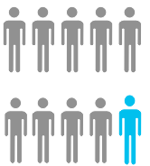
Post-secondary education is the surest route to economic mobility in the United States but the rising cost of college discourages many students from pursuing higher education. Adults with college degrees earn roughly twice as much over their lifetimes as those with a high school diploma or less.

In the absence of college savings or other financial resources, low-income students face the prospect of large amounts of debt, dropping out or never attending college. The result is that less than 10% of students from low-income families graduate from college by their mid-twenties.

THE SOLUTION: COLLEGE SAVINGS AND THE 1:1 FUND
The 1:1 Fund addresses this challenge by raising funds to match the contributions of low-income, minority and first-generation students in special Children's Savings Accounts (CSAs). Research shows that low-income children with even $500 or less in a children’s savings account are three times more likely to enroll in college and four times more likely to graduate than children who don’t have an account. When kids and families save for college early, it changes the equation. With money in the bank, college attendance becomes an expectation.
1:1 FUND IMPACT

The 1:1 Fund officially launched in September 2012 with local child savings programs in the San Francisco Bay Area and Mississippi. To date, the 1:1 Fund has:

- Raised more than $1.4 million in matching dollars from over 1000 donors
- Partners have served over 128,000 students that now hold over $10 million in total college savings
- Grown to 12 partners in eleven states, including our newest partners in Durham, NC, El Monte, CA, and Lansing, MI.

HOW THE 1:1 FUND WORKS

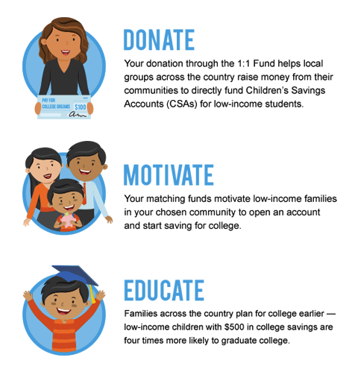
The 1:1 Fund partners with leading local college savings programs that work with low-income children saving and striving for college. The 1:1 Fund platform enables these local college savings programs to engage their networks to raise critical matching dollars, and then use these matching dollars to incentivize savers and their families. As shown below, supporters and donors are extremely important to the process.

Core support for the 1:1 Fund has come from:

Citi Foundation
Google.org
LinkedIn for Good Foundation
Lisa and Douglas Goldman Foundation
Marcled Foundation
Prudential
Richard Goldman Family Foundation

San Francisco Foundation
TomKat Charitable Trust
Tuck’s R.U.S.H. for Literacy
Wallace A. Gerbode Foundation
Walter and Elise Haas Fund
W.K. Kellogg Foundation
And generous individual donors

