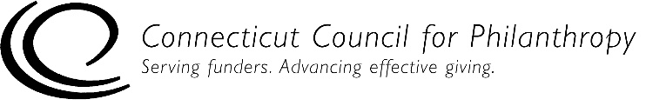
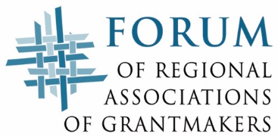

Accountability Self-Assessment for Staffed Private Foundations
ADMINISTRATION

This self-assessment tool is designed to help you determine if your staffed private foundation (family, independent or corporate) is complying with key federal laws and regulations and is engaging in generally recommended good practices for being accountable to the public. Addressing issues of accountability is an ongoing process for an organization, and this tool is designed to help organizations with that process.

This Administration tool is for private foundations with one or more full-time or part-time staff people. If your foundation is not staffed, please use the accountability self-assessment tool for unstaffed private foundations.

Complete directions for how to use this tool are provided in a separate document.

Please note that this self-assessment tool is designed to allow some flexibility in how it is used and interpreted, since not all of the practices listed in the self-assessment tool will be applicable to every foundation, particularly smaller foundations. But the tool provides a solid framework to help foundations assess how well they are achieving their goals to be ethical and accountable organizations.

Foundation Name:
Date(s) of Self-Assessment:
Name and Title of Person(s) Conducting
Self-Assessment:

Administration
This section focuses on a foundation’s internal operation and administration of its records and other information, technology and systems.

Level 1 – Legal Compliance
Records Retention & Management | Yes | No | NA
1. We have a written, mandatory record retention and destruction policy.³
2. For any grants we make to an individual for travel, study or similar purposes, we retain the following information on these grants for four years after completion of the use of funds:
- All information we secured to evaluate the qualifications of potential grantees.
- Identification of grantees (including whether grantee is a disqualified person).
- Specification of the amount and purpose of each grant.
- Follow-up information that we obtained in complying with these record retention requirements.

³ The law does not require a private foundation to have a record retention and destruction policy, but having such a policy is becoming increasingly critical to protect a foundation from legal liability. Although provisions of the Sarbanes-Oxley Act of 2002 apply only to public companies, the Act has made it easier for the government to prosecute cases where individuals and organizations (including charitable institutions and their managers) have obstructed justice by destroying documents. And there are growing calls from federal and state regulators to mandate Sarbanes-Oxley-type reforms for charities.

Level 2 – Good Practices for Accountability
 | True | Mostly  True | Some-  times  True | Never True | NA
1. Our general records are retained for 7 years, unless some other period of time has been determined by our attorneys to be reasonable to ensure that the information in the records is available as long as it may become material in the administration of any law.
2. All our grant decisions are clearly recorded and appropriately stored.
3. We have automatic daily backup of data and a safe data storage policy.
4. A computer expert has reviewed and verified that our computer and network security is adequate to protect our information and assets.
Level 3 – Practices of Excellence for Accountability
 | True | Mostly  True | Some-  times  True | Never True | NA
1 We actively seek a diverse range of candidates when selecting consultants, investment managers, legal counsel, auditing firms and other vendors.
2. We have systems in place that allow us to easily track the grant history and application history of grantees and grant applicants.

