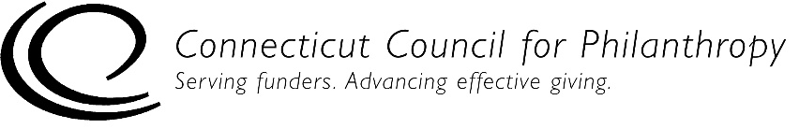 |  | 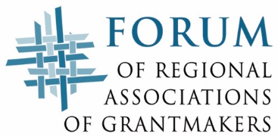

Accountability Self-Assessment for Unstaffed Private Foundations
COMMUNICATIONS/DISCLOSURE
This self-assessment tool is designed to help you determine if your unstaffed private foundation (family, independent or corporate) is complying with key federal laws and regulations and is engaging in generally recommended good practices for being accountable to the public. Addressing issues of accountability is an ongoing process for an organization, and this tool is designed to help organizations with that process.

This Communications/Disclosure tool is for private foundations with no full-time or part-time staff. If your foundation has one or more full-time or part-time staff people, please use the accountability self-assessment tool for staffed private foundations.

Complete directions for how to use this tool are provided in a separate document.

Please note that this self-assessment tool is designed to allow some flexibility in how it is used and interpreted, since not all of the practices listed in the self-assessment tool will be applicable to every foundation, particularly smaller foundations. But the tool provides a solid framework to help foundations assess how well they are achieving their goals to be ethical and accountable organizations.

Foundation Name:
Date(s) of Self-Assessment:
Name and Title of Person(s) Conducting
Self-Assessment:

Communications/Disclosure
This section focuses on a foundation’s openness and transparency in communicating and disclosing key information about the organization to its constituents and the broader public.

Level 1 – Legal Compliance
990-PF & Other Filings | Yes | No | NA
1. We file our 990-PF by the legal deadline.
2. On our 990-PF, we provide information on our grantmaking guidelines and application process. If we do not accept unsolicited grant proposals, we indicate this on the form.
3. On our 990-PF, we provide a complete list of grants paid and approved, with a grant description.
4. On our 990-PF, we provide a complete and accurate list of all officers and board members, with a complete description of each person’s compensation and time devoted to the position.
5. We have retained and make available for public inspection, without charge, a copy of our original and amended 990-PF and any 990-Ts for the last three years and of our exemption application and related documents (unless we filed our exemption application before July 15, 1987, and did not have a copy of the application on that date).
6. We provide copies of our 990-PF and exemption application to anyone who requests them either in person (on a same-day basis) or in writing (within 30 days of the request) OR we make our 990-PF and exemption application available free on the Web as exact images of the originals.
7. We provide copies of our 990-PF, any 990-Ts and exemption application to anyone who requests them either in person (on a same-day basis) or in writing (within 30 days of the request) OR we make our 990-PF and exemption application available free on the Web as exact images of the originals.

Registration  If we are a newly formed foundation: | Yes | No | NA
1. We have filed Form 1023 for recognition by the IRS as a tax-exempt organization.
2. We have filed articles of incorporation with the appropriate fee with the Secretary of State or other appropriate state office.
3. We have applied for state tax exemption, if it is required in our state.
4. We have filed any additional registration forms that our state may require for nonprofit corporations or charitable trusts.

Level 2 – Good Practices for Accountability
990-PF | True | Mostly  True | Some-  times  True | Never True | NA
1. Our 990-PF is reviewed and approved by our board chair before it is submitted, to ensure it is accurate, complete and filed on time.
2. Our 990-PF is signed by our highest-ranking officer.
3. We file our 990-PF in a timely manner, without extensions unless required by ordinary circumstances.

Transparency | True | Mostly  True | Some-  times  True | Never True | NA
1. We make available information on our organization and our grantmaking guidelines and procedures to GuideStar and the Foundation Center’s directory.
2. We make available information on our organization and our grantmaking guidelines and procedures to any directory of grantmakers in our region published by a regional association of grantmakers or other recognized publisher.
3. If we accept unsolicited grant proposals, we make readily available a full and clear description of our grantmaking guidelines and application process through our 990-PF, grantmaker directory entries and/or other communications vehicles as appropriate, including the following information:
Program interests, funding priorities, and any restrictions.
Geographic limitations, if any.
How to apply for grants, including preferred application format.
Application deadlines, if any.
Dates of grants meetings.
Policies and practices related to multi-year funding.
Average size and range of grants made.
When and how grant requests will be acknowledged, and how applicants will be kept informed of the status of their requests.
Estimated turnaround time for grant applications.
A list of grants made in one or more previous years, including grant amount, recipient and purpose.
4. If we do not accept unsolicited grant proposals, we clearly indicate this in our grantmaker directory entries and/or other communications vehicles as appropriate.

Level 3 – Practices of Excellence for Accountability
990-PF | True | Mostly  True | Some-  times  True | Never True | NA
1. We file our 990-PF electronically or are planning a move to electronic filing.
2. We post our 990-PF prominently on our website (if we have a website).
3. We share our completed 990-PF with our board, or at least those portions of the form that may be of most interest to the public.

Transparency | True | Mostly  True | Some-  times  True | Never True | NA
1. We make readily available information about our finances, operations, governance and impact through our annual report, website and/or other communications vehicles as appropriate, including the following information:
Vision, mission and goals.
Statement of values and code of ethics.
Founding donor’s intent.
Most recent audited financial statements.
Our funding programs and impact of our work.
Results of any research we may fund.
Accreditations we hold or certifications/standards we meet.
Names of board members.
Names and titles of officers.
Bylaws or charter documents.
Other relevant policies and documents.
Address and name of an individual to contact for information.
Phone number, office location and office hours (if we maintain an office).

