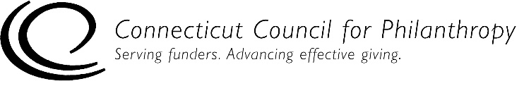

Accountability Self-Assessment for Staffed Private Foundations
EVALUATIONS

This self-assessment tool is designed to help you determine if your staffed private foundation (family, independent or corporate) is complying with key federal laws and regulations and is engaging in generally recommended good practices for being accountable to the public. Addressing issues of accountability is an ongoing process for an organization, and this tool is designed to help organizations with that process.

This Evaluation tool is for private foundations with one or more full-time or part-time staff people. If your foundation is not staffed, please use the accountability self-assessment tool for unstaffed private foundations.

Complete directions for how to use this tool are provided in a separate document.

Please note that this self-assessment tool is designed to allow some flexibility in how it is used and interpreted, since not all of the practices listed in the self-assessment tool will be applicable to every foundation, particularly smaller foundations. But the tool provides a solid framework to help foundations assess how well they are achieving their goals to be ethical and accountable organizations.

Foundation Name:
Date(s) of Self-Assessment:
Name and Title of Person(s) Conducting
Self-Assessment:

Evaluation
This section focuses on a foundation’s work to evaluate and assess the effectiveness and/or efficiency of its grantmaking and its internal operations.

Level 1 – Legal Compliance

There are no legal compliance issues for this section.

Level 2 – Good Practices for Accountability
 | True | Mostly  True | Some-  times  True | Never True | NA
1. We periodically evaluate the efficiency and effectiveness of our organization’s operations and procedures.
2. We periodically evaluate the effectiveness and impact of our grantmaking.
3. Our evaluations relate to our mission, assessing whether our programs and operations are attaining the goals and objectives explicit in our mission.
4. If we use an outside evaluator, we take steps to ensure that the evaluator discloses any roles or relationships that might pose a conflict of interest (or appearance of a conflict) in its role as an evaluator.
5. We disclose any actual or potential conflicts of interests with outside evaluators in reports of the evaluation results.
6. We involve our board and staff in our evaluations.

Level 3 – Practices of Excellence for Accountability
 | True | Mostly  True | Some-  times  True | Never True | NA
1. Our evaluations include perspectives from outside our organization (e.g., current and past grantees, grant applicants, the broader community being served, other philanthropic organizations).
2. We take steps to ensure confidentiality for grant applicants and recipients involved in our evaluation process.
3. We have ingrained evaluation into the day-to-day operations of our organization, rather than treating it as a single event.
4. We use evaluation as an ongoing process of organizational learning, rather than as a discrete “report card” process.

 | True | Mostly  True | Some-  times  True | Never True | NA
5. We share successes, failures and lessons learned from our evaluations with our board and staff.
6. We share successes, failures and lessons learned from our evaluations externally, particularly when using an outside evaluator, including with grantees, policymakers and other grantmakers.
7. We utilize external evaluators when appropriate and feasible.

