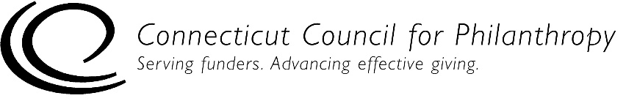 |  | 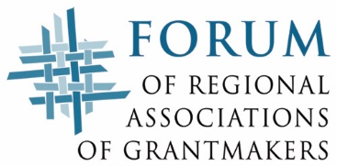

Accountability Self-Assessment for Unstaffed Private Foundations
MISSION/STRATEGY
This self-assessment tool is designed to help you determine if your unstaffed private foundation (family, independent or corporate) is complying with key federal laws and regulations and is engaging in generally recommended good practices for being accountable to the public. Addressing issues of accountability is an ongoing process for an organization, and this tool is designed to help organizations with that process.

This Mission/Strategy tool is for private foundations with no full-time or part-time staff. If your foundation has one or more full-time or part-time staff people, please use the accountability self-assessment tool for staffed private foundations.

Complete directions for how to use this tool are provided in a separate document.

Please note that this self-assessment tool is designed to allow some flexibility in how it is used and interpreted, since not all of the practices listed in the self-assessment tool will be applicable to every foundation, particularly smaller foundations. But the tool provides a solid framework to help foundations assess how well they are achieving their goals to be ethical and accountable organizations.

Foundation Name:
Date(s) of Self-Assessment:
Name and Title of Person(s) Conducting
Self-Assessment:

Mission & Strategy
This section focuses on a foundation’s strategies to ensure that it achieves the best possible results from its grantmaking.

Level 1 – Legal Compliance

There are no legal compliance issues for this section.

Level 2 – Good Practices for Accountability
 | True | Mostly  True | Some-  times  True | Never True | NA
1. We have a written mission statement, approved by our board, that clearly and succinctly describes what business we are in, what we do, for whom, why and how.
2. We review our mission every 3-5 years to determine if it continues to meet changing community needs.
3. We periodically review our charter and other donor instructions to determine whether they need to be amended or re-interpreted to meet changing community needs in ways that reasonably honor the donor’s intent.
4. We periodically review our grantmaking priorities and objectives to help ensure that our grantmaking remains relevant and responsive, taking into consideration such factors as changing needs and capacities of the communities we support, legislation or other government initiatives, and policies and activities of other grantmakers that may affect our funding.

Level 3 – Practices of Excellence for Accountability
 | True | Mostly  True | Some-  times  True | Never True | NA
1. We have a written strategic plan to guide our activities.
2. We have a written operational plan to guide our activities.

