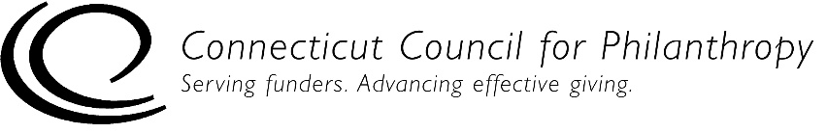 |  | 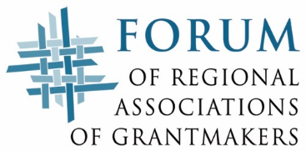

Accountability Self-Assessment for Unstaffed Private Foundations
PUBLIC POLICY
This self-assessment tool is designed to help you determine if your unstaffed private foundation (family, independent or corporate) is complying with key federal laws and regulations and is engaging in generally recommended good practices for being accountable to the public. Addressing issues of accountability is an ongoing process for an organization, and this tool is designed to help organizations with that process.

This Public Policy tool is for private foundations with no full-time or part-time staff. If your foundation has one or more full-time or part-time staff people, please use the accountability self-assessment tool for staffed private foundations.

Complete directions for how to use this tool are provided in a separate document.

Please note that this self-assessment tool is designed to allow some flexibility in how it is used and interpreted, since not all of the practices listed in the self-assessment tool will be applicable to every foundation, particularly smaller foundations. But the tool provides a solid framework to help foundations assess how well they are achieving their goals to be ethical and accountable organizations.

Foundation Name:
Date(s) of Self-Assessment:
Name and Title of Person(s) Conducting
Self-Assessment:

Public Policy
This section focuses on a foundation’s engagement in the public policy process, including funding and/or participating in lobbying and advocacy activities.

Level 1 – Legal Compliance
Funding Advocacy & Lobbying | Yes | No | NA
1. We do not engage in direct lobbying, or the funding of such lobbying, unless it is for one or more of the following activities:
- Fund or present nonpartisan analysis, study or research that was made widely available.
- Engage in examinations and discussions of broad social, economic and similar problems not connected to specific legislative proposals.
- Provide testimony or other technical assistance to governmental body or committee, pursuant to a written request from the governmental body or committee.
- Address proposed legislation that would affect the existence of our foundation, its powers and duties, its tax-exempt status, or the deductibility of contributions to the foundation.
- Fund a public charity’s membership communications that contain legislative information but no legislative call to action (if the charity elected to be governed by IRC Section 501(h)).
- Present information to a legislative body about a program that is, or may be, funded by both the foundation and the government.
2. We do not provide public charities with any grants that are earmarked to be used for lobbying.
3. We do not make any grants to support voter education or voter registration activities that are overtly or implicitly partisan in the persons targeted or the messages conveyed.
4. If we fund nonpartisan voter registration activities, we follow all procedures required by the IRS in Section 4945(f).
5. We do not make grants for any project involving lobbying activity in which our total grants for that project during the year exceed the project’s budgeted non-lobbying expenses.

Political Campaign Involvement | Yes | No | NA
1. We do not to make any campaign contributions to, or any expenditures on behalf of, candidates for public office.
2. We do not endorse any candidates for public office on behalf of the foundation.
3. We do not communicate anything on behalf of the foundation that explicitly or implicitly favors any candidates for public office.
4. Our board members do not use foundation facilities, equipment, personnel or other resources to provide support to, or oppose, a candidate for public office or a political campaign.

Employing Lobbyists  If we employ a lobbyist: | Yes | No | NA
1. We register and file semiannual reports with the Secretary of the U.S. Senate and the Clerk of the U.S. House of Representatives, if we expected to incur, or did incur, in-house lobbying expenses at the federal level exceeding $24,500 in a semiannual period.
2. We file any reports that may be required by state law.

Level 2 – Good Practices for Accountability

There are no level 2 practices for this section.

Level 3 – Practices of Excellence for Accountability
Participating in Advocacy | True | Mostly  True | Some-  times  True | Never True | NA
1. We have considered ways to advocate for the charitable sector, or to support such efforts, within the limits of the law.
2. We have considered ways to advocate publicly for issues that relate to our mission and values, or to support such efforts, within the limits of the law.

